Chapter 1 Found Dog Assignment
Section | Points Received | Total
Headline: CAPS |  | 2
Headline: Font Style |  | 2
Headline: Font Shading |  | 2
Headline: Centered |  | 3
Photos: Shaded Border |  | 2
Photos: Two Images |  | 3
Page Border |  | 3
Copy: Typed, no grammar/spelling errors |  | 5
Bullet Points |  | 2
Bailey Text in Italics and colors |  | 2
Signature: BOLD |  | 2
Signature: Phone # is Underlined |  | 2
TOTAL |  | 30

Found Dog Assignment
Section | Points Received | Total
Headline: CAPS |  | 2
Headline: Font Style |  | 2
Headline: Font Shading |  | 2
Headline: Centered |  | 3
Photos: Shaded Border |  | 2
Photos: Two Images |  | 3
Page Border |  | 3
Copy: Typed, no grammar/spelling errors |  | 5
Bullet Points |  | 2
Bailey Text in Italics and colors |  | 2
Signature: BOLD |  | 2
Signature: Phone # is Underlined |  | 2
TOTAL |  | 30

Chapter 2 Research Paper
Section | Points Received | Total
Marino (or their last name) & Page Number (all #s correct) |  | 5
Footnote mark (1 pt for somewhere in the document, 2 points for being in the right place) |  | 2
Works Cited page - some italics, underline |  | 5
2 Typed pages + work cited page |  | 3
TOTAL |  | 15

Chapter 3 Business Letter
Section | Points Received | Total
Headline (Heartland): in CAPS & Centered |  | 2
Headline (Heartland): in a shaded box and spelled correctly |  | 2
Tractor Image is easy to move in the document |  | 2
Tractor image has transparent background |  | 2
Address: 323 Pine Avenue; Centered |  | 2
Address: Symbols (like bullet points) |  | 2
Date Line is tabbed correctly |  | 1
Address: typed correctly and no grammar errors |  | 2
Dear Mr. Wilcox with colon or comma |  | 2
Body: Heartland Tractor Magazine is italicized |  | 2
Body: Moderate Margin Settings |  | 2
Signature is aligned with date line |  | 1
Total |  | 22

Word #4 - e-Flyer
Section | Points Received | Total
Photos (2) |  | 4
Photos with formatting |  | 4
Short Narrative |  | 2
Bulleted Skills (3) |  | 3
Page Border |  | 2
Grammar & Spelling |  | 5
Overall Appearance |  | 5
Total |  | 25

Word #4 - Resume
Section | Points Received | Total
Heading: n |  | 5
Skills, Experience, Activities, etc |  | 10
Formatting |  | 5
Grammar & Spelling |  | 5
Total |  | 25

Word #4 - Cover Letter
Section | Points Received | Total
Header |  | 5
Introduction |  | 5
Body Paragraph |  | 5
Closing Paragraph |  | 5
Grammar & Spelling |  | 5
Total |  | 25

Power Point: 25, 15, 27 = 67 pts
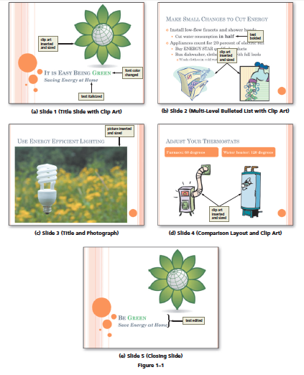
Chapter 1 - PowerPoint - Being Green

Slide 1: Green is Green |  | 2
Slide 1: Clip Art Image |  | 2
ALL Slides: Transitions |  | 3
Slide 2: “In half” is BOLD |  | 2
Slide 2: 6 bullet points (check page) |  | 6
Slide 3: Title & Photo |  | 2
Slide 4: Title, Layout & Two Photos |  | 4
Slide 5: Green is Green |  | 2
Slide 5: Save Energy is Italics |  | 2
TOTAL |  | 25
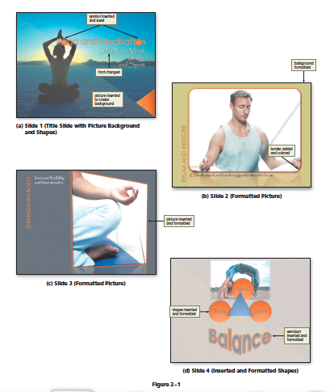
Chapter 2 - PowerPoint - Yoga & Meditation

Slide 1: Sun Symbol ____ 2pts
Slide 1: Photo ____ 1 pts
Slide 1: Theme ____ 1 pts
Slide 2: Photo (Border & Shadow) ____ 2 pts
Slide 2: Photo (Background) ____ 1 pt
Slide 3: Photo (Formatted Photo) ____ 2 pts
Slide 4: Shapes ____ 4 pts
Slide 4: WordArt (color & design) ____ 2 pts

Name: _________________________

Chapter 1 - PowerPoint - Being Green
Slide 1: Green is Green |  | 2
Slide 1: Clip Art Image |  | 2
ALL Slides: Transitions |  | 3
Slide 2: “In half” is BOLD |  | 2
Slide 2: 6 bullet points (check page) |  | 6
Slide 3: Title & Photo |  | 2
Slide 4: Title, Layout & Two Photos |  | 4
Slide 5: Green is Green |  | 2
Slide 5: Save Energy is Italics |  | 2
TOTAL |  | 25
Chapter 2 - PowerPoint - Yoga & Meditation

Slide 1: Sun Symbol ____ 2pts
Slide 1: Photo ____ 1 pts
Slide 1: Theme ____ 1 pts
Slide 2: Photo (Border & Shadow) ____ 2 pts
Slide 2: Photo (Background) ____ 1 pt
Slide 3: Photo (Formatted Photo) ____ 2 pts
Slide 4: Shapes ____ 4 pts
Slide 4: WordArt (color & design) ____ 2 pts

Birds Power Point

Slide 1: Bird Photo with Yellow Beak (2 pts) and transparent background (2 pts) |  | 4
Slide 1: Music Playing |  | 2
Slide 1: Slide Notes (2 pt/sentence) |  | 8
Slide 2: No spelling errors |  | 2
Slide 2: Bird image with brown beak |  | 2
Slide 2: Slide Notes (2 pt/sentence) |  | 2
Slide 3: Video plays |  | 2
Slide 3: Speaker Notes (2 pt/sentence) |  | 6
TOTAL |  | 28

Birds Power Point

Slide 1: Bird Photo with Yellow Beak (2 pts) and transparent background (2 pts) |  | 4
Slide 1: Music Playing |  | 2
Slide 1: Slide Notes (2 pt/sentence) |  | 8
Slide 2: No spelling errors |  | 2
Slide 2: Bird image with brown beak |  | 2
Slide 2: Slide Notes (2 pt/sentence) |  | 2
Slide 3: Video plays |  | 2
Slide 3: Speaker Notes (2 pt/sentence) |  | 6
TOTAL |  | 28

Slide 1: Bird Photo with Yellow Beak (2 pts) and transparent background (2 pts) |  | 4
Slide 1: Music Playing |  | 2
Slide 1: Slide Notes (2 pt/sentence) |  | 8
Slide 2: No spelling errors |  | 2
Slide 2: Bird image with brown beak |  | 2
Slide 2: Slide Notes (2 pt/sentence) |  | 2
Slide 3: Video plays |  | 2
Slide 3: Speaker Notes (2 pt/sentence) |  | 6
TOTAL |  | 28

Top Ten Power Point

Six Photos (3 each) _______ 18 Six Photos ____ 18
Symbols (2 each) _______ 9 Symbols ____ 9
Word Art (2 each) _______ 4 Word Art ____ 4
Slide Master _______ 10 Slide Master ____ 10
10 Slides _______ 11 10 Slides ____ 11
Transitions _______ 11 Transitions ____ 11
Creativity _______ 5 Creativity ____ 5
Grammar _______ 5 Grammar ____ 5
Slide Title _______ 2 Slide Title ____ 2

Six Photos (3 each) _______ 18 Six Photos ____ 18
Symbols (2 each) _______ 9 Symbols ____ 9
Word Art (2 each) _______ 4 Word Art ____ 4
Slide Master _______ 10 Slide Master ____ 10
10 Slides _______ 11 10 Slides ____ 11
Transitions _______ 11 Transitions ____ 11
Creativity _______ 5 Creativity ____ 5
Grammar _______ 5 Grammar ____ 5
Slide Title _______ 2 Slide Title ____ 2

Six Photos (3 each) _______ 18 Six Photos ____ 18
Symbols (2 each) _______ 9 Symbols ____ 9
Word Art (2 each) _______ 4 Word Art ____ 4
Slide Master _______ 10 Slide Master ____ 10
10 Slides _______ 11 10 Slides ____ 11
Transitions _______ 11 Transitions ____ 11
Creativity _______ 5 Creativity ____ 5
Grammar _______ 5 Grammar ____ 5
Slide Title _______ 2 Slide Title ____ 2

Excel Rubric
Chapter 1: Save Sable River Foundation (30)
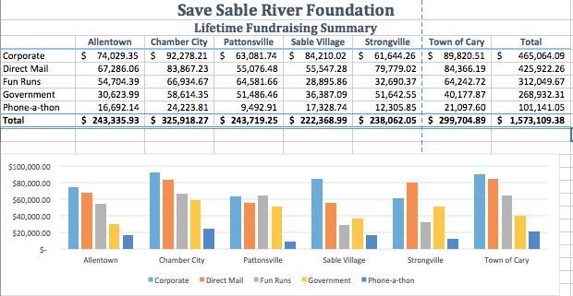

Chapter 2: The Mobile Masses Payroll Report (20)

Chapter 3: Modern Music Shops (10)
Rows 1-8 and Modern Music Shops (shaded) - 2pts
July - Chart - typed and aligned diagonally - 1pt
July Total Expenses (B23): $1,463,397.72 - 1pt
Chart column (ROW I) with lines - 1pt
Total Total Expenses (H23): $14,778,748.04 - 2pts
Cell I11 =NOW() 1pt
3D Pie Chart
Six Month Financial Project (Title) - 1pt
Pie Chart - 6 pie pieces - 1pt

Excel Portfolio Project

10 Stocks 10 pts
Average (1 pt each) 6 pts
Highest 7 pts
Lowest 7 pts
Total Initial Cost (under 25K) 5 pts (0 pts if over 25K)
Formulas 40 pts (each per column F, H, I, J)

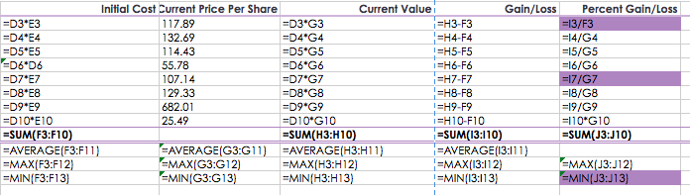

Microsoft Word Assignment - Final
Name: ___________________ Name: ___________________
Title _____ Flier ______
Short Intro/Text _____ Short Intro/Text ______
Bullet Points _____ Bullet Points ______
Photo _____ Photo ______
Table _____ Table ______
Page Border _____ Page Border ______
Spelling & Grammar _____ Spelling & Grammar ______

Name: ___________________ Name: ___________________
Title _____ Flier ______
Short Intro/Text _____ Short Intro/Text ______
Bullet Points _____ Bullet Points ______
Photo _____ Photo ______
Table _____ Table ______
Page Border _____ Page Border ______
Spelling & Grammar _____ Spelling & Grammar ______

Name: ___________________ Name: ___________________
Title _____ Flier ______
Short Intro/Text _____ Short Intro/Text ______
Bullet Points _____ Bullet Points ______
Photo _____ Photo ______
Table _____ Table ______
Page Border _____ Page Border ______
Spelling & Grammar _____ Spelling & Grammar ______

Name: ___________________ Name: ___________________
Title _____ Flier ______
Short Intro/Text _____ Short Intro/Text ______
Bullet Points _____ Bullet Points ______
Photo _____ Photo ______
Table _____ Table ______
Page Border _____ Page Border ______
Spelling & Grammar _____ Spelling & Grammar ______

Name: ___________________ Name: ___________________
Title _____ Flier ______
Short Intro/Text _____ Short Intro/Text ______
Bullet Points _____ Bullet Points ______
Photo _____ Photo ______
Table _____ Table ______
Page Border _____ Page Border ______
Spelling & Grammar _____ Spelling & Grammar ______

Powerpoint Assignment - FINAL

Name: ____________________ Name: _________________________
Each slide to have Speaker Notes (2 pts). Each slide to have Speaker Notes (2 pts).
Slide 1: University Name ___ / 5 pts Slide 1: University Name ___ / 5 pts
Slide 2: University Majors ___ / 5 pts Slide 2: University Majors ___ / 5 pts
Slide 3: Admission Reqs ___ / 5 pts Slide 3: Admission Reqs ___ / 5 pts
Slide 4: Tuition Costs ___ / 5 pts Slide 4: Tuition Costs ___ / 5 pts
Slide 5: Additional Info ___ / 5 pts Slide 5: Additional Info ___ / 5 pts
Grammar/Spelling ___ / 5 pts Grammar/Spelling ___ / 5 pts
Slide Master ___ / 1 pts Slide Master ___ / 2 pts
Word Art ___ / 1 pts Word Art ___ / 2 pts
Total: ___ / 30 pts Total: ___ / 30 pts

Each slide to have Speaker Notes (2 pts). Each slide to have Speaker Notes (2 pts).
Slide 1: University Name ___ / 5 pts Slide 1: University Name ___ / 5 pts
Slide 2: University Majors ___ / 5 pts Slide 2: University Majors ___ / 5 pts
Slide 3: Admission Reqs ___ / 5 pts Slide 3: Admission Reqs ___ / 5 pts
Slide 4: Tuition Costs ___ / 5 pts Slide 4: Tuition Costs ___ / 5 pts
Slide 5: Additional Info ___ / 5 pts Slide 5: Additional Info ___ / 5 pts
Grammar/Spelling ___ / 5 pts Grammar/Spelling ___ / 5 pts
Slide Master ___ / 1 pts Slide Master ___ / 2 pts
Word Art ___ / 1 pts Word Art ___ / 2 pts
Total: ___ / 30 pts Total: ___ / 30 pts

Each slide to have Speaker Notes (2 pts). Each slide to have Speaker Notes (2 pts).
Slide 1: University Name ___ / 5 pts Slide 1: University Name ___ / 5 pts
Slide 2: University Majors ___ / 5 pts Slide 2: University Majors ___ / 5 pts
Slide 3: Admission Reqs ___ / 5 pts Slide 3: Admission Reqs ___ / 5 pts
Slide 4: Tuition Costs ___ / 5 pts Slide 4: Tuition Costs ___ / 5 pts
Slide 5: Additional Info ___ / 5 pts Slide 5: Additional Info ___ / 5 pts
Grammar/Spelling ___ / 5 pts Grammar/Spelling ___ / 5 pts
Slide Master ___ / 1 pts Slide Master ___ / 2 pts
Word Art ___ / 1 pts Word Art ___ / 2 pts
Total: ___ / 30 pts Total: ___ / 30 pts

Each slide to have Speaker Notes (2 pts). Each slide to have Speaker Notes (2 pts).
Slide 1: University Name ___ / 5 pts Slide 1: University Name ___ / 5 pts
Slide 2: University Majors ___ / 5 pts Slide 2: University Majors ___ / 5 pts
Slide 3: Admission Reqs ___ / 5 pts Slide 3: Admission Reqs ___ / 5 pts
Slide 4: Tuition Costs ___ / 5 pts Slide 4: Tuition Costs ___ / 5 pts
Slide 5: Additional Info ___ / 5 pts Slide 5: Additional Info ___ / 5 pts
Grammar/Spelling ___ / 5 pts Grammar/Spelling ___ / 5 pts
Slide Master ___ / 1 pts Slide Master ___ / 2 pts
Word Art ___ / 1 pts Word Art ___ / 2 pts
Total: ___ / 30 pts Total: ___ / 30 pts

Each slide to have Speaker Notes (2 pts). Each slide to have Speaker Notes (2 pts).
Slide 1: University Name ___ / 5 pts Slide 1: University Name ___ / 5 pts
Slide 2: University Majors ___ / 5 pts Slide 2: University Majors ___ / 5 pts
Slide 3: Admission Reqs ___ / 5 pts Slide 3: Admission Reqs ___ / 5 pts
Slide 4: Tuition Costs ___ / 5 pts Slide 4: Tuition Costs ___ / 5 pts
Slide 5: Additional Info ___ / 5 pts Slide 5: Additional Info ___ / 5 pts
Grammar/Spelling ___ / 5 pts Grammar/Spelling ___ / 5 pts
Slide Master ___ / 1 pts Slide Master ___ / 2 pts
Word Art ___ / 1 pts Word Art ___ / 2 pts
Total: ___ / 30 pts Total: ___ / 30 pts

Each slide to have Speaker Notes (2 pts). Each slide to have Speaker Notes (2 pts).
Slide 1: University Name ___ / 5 pts Slide 1: University Name ___ / 5 pts
Slide 2: University Majors ___ / 5 pts Slide 2: University Majors ___ / 5 pts
Slide 3: Admission Reqs ___ / 5 pts Slide 3: Admission Reqs ___ / 5 pts
Slide 4: Tuition Costs ___ / 5 pts Slide 4: Tuition Costs ___ / 5 pts
Slide 5: Additional Info ___ / 5 pts Slide 5: Additional Info ___ / 5 pts
Grammar/Spelling ___ / 5 pts Grammar/Spelling ___ / 5 pts
Slide Master ___ / 1 pts Slide Master ___ / 2 pts
Word Art ___ / 1 pts Word Art ___ / 2 pts
Total: ___ / 30 pts Total: ___ / 30 pts

Each slide to have Speaker Notes (2 pts). Each slide to have Speaker Notes (2 pts).
Slide 1: University Name ___ / 5 pts Slide 1: University Name ___ / 5 pts
Slide 2: University Majors ___ / 5 pts Slide 2: University Majors ___ / 5 pts
Slide 3: Admission Reqs ___ / 5 pts Slide 3: Admission Reqs ___ / 5 pts
Slide 4: Tuition Costs ___ / 5 pts Slide 4: Tuition Costs ___ / 5 pts
Slide 5: Additional Info ___ / 5 pts Slide 5: Additional Info ___ / 5 pts
Grammar/Spelling ___ / 5 pts Grammar/Spelling ___ / 5 pts
Slide Master ___ / 1 pts Slide Master ___ / 2 pts
Word Art ___ / 1 pts Word Art ___ / 2 pts
Total: ___ / 30 pts Total: ___ / 30 pts

Each slide to have Speaker Notes (2 pts). Each slide to have Speaker Notes (2 pts).
Slide 1: University Name ___ / 5 pts Slide 1: University Name ___ / 5 pts
Slide 2: University Majors ___ / 5 pts Slide 2: University Majors ___ / 5 pts
Slide 3: Admission Reqs ___ / 5 pts Slide 3: Admission Reqs ___ / 5 pts
Slide 4: Tuition Costs ___ / 5 pts Slide 4: Tuition Costs ___ / 5 pts
Slide 5: Additional Info ___ / 5 pts Slide 5: Additional Info ___ / 5 pts
Grammar/Spelling ___ / 5 pts Grammar/Spelling ___ / 5 pts
Slide Master ___ / 1 pts Slide Master ___ / 2 pts
Word Art ___ / 1 pts Word Art ___ / 2 pts
Total: ___ / 30 pts Total: ___ / 30 pts

Each slide to have Speaker Notes (2 pts). Each slide to have Speaker Notes (2 pts).
Slide 1: University Name ___ / 5 pts Slide 1: University Name ___ / 5 pts
Slide 2: University Majors ___ / 5 pts Slide 2: University Majors ___ / 5 pts
Slide 3: Admission Reqs ___ / 5 pts Slide 3: Admission Reqs ___ / 5 pts
Slide 4: Tuition Costs ___ / 5 pts Slide 4: Tuition Costs ___ / 5 pts
Slide 5: Additional Info ___ / 5 pts Slide 5: Additional Info ___ / 5 pts
Grammar/Spelling ___ / 5 pts Grammar/Spelling ___ / 5 pts
Slide Master ___ / 1 pts Slide Master ___ / 2 pts
Word Art ___ / 1 pts Word Art ___ / 2 pts
Total: ___ / 30 pts Total: ___ / 30 pts

Each slide to have Speaker Notes (2 pts). Each slide to have Speaker Notes (2 pts).
Slide 1: University Name ___ / 5 pts Slide 1: University Name ___ / 5 pts
Slide 2: University Majors ___ / 5 pts Slide 2: University Majors ___ / 5 pts
Slide 3: Admission Reqs ___ / 5 pts Slide 3: Admission Reqs ___ / 5 pts
Slide 4: Tuition Costs ___ / 5 pts Slide 4: Tuition Costs ___ / 5 pts
Slide 5: Additional Info ___ / 5 pts Slide 5: Additional Info ___ / 5 pts
Grammar/Spelling ___ / 5 pts Grammar/Spelling ___ / 5 pts
Slide Master ___ / 1 pts Slide Master ___ / 2 pts
Word Art ___ / 1 pts Word Art ___ / 2 pts
Total: ___ / 30 pts Total: ___ / 30 pts

Each slide to have Speaker Notes (2 pts). Each slide to have Speaker Notes (2 pts).
Slide 1: University Name ___ / 5 pts Slide 1: University Name ___ / 5 pts
Slide 2: University Majors ___ / 5 pts Slide 2: University Majors ___ / 5 pts
Slide 3: Admission Reqs ___ / 5 pts Slide 3: Admission Reqs ___ / 5 pts
Slide 4: Tuition Costs ___ / 5 pts Slide 4: Tuition Costs ___ / 5 pts
Slide 5: Additional Info ___ / 5 pts Slide 5: Additional Info ___ / 5 pts
Grammar/Spelling ___ / 5 pts Grammar/Spelling ___ / 5 pts
Slide Master ___ / 1 pts Slide Master ___ / 2 pts
Word Art ___ / 1 pts Word Art ___ / 2 pts
Total: ___ / 30 pts Total: ___ / 30 pts

Each slide to have Speaker Notes (2 pts). Each slide to have Speaker Notes (2 pts).
Slide 1: University Name ___ / 5 pts Slide 1: University Name ___ / 5 pts
Slide 2: University Majors ___ / 5 pts Slide 2: University Majors ___ / 5 pts
Slide 3: Admission Reqs ___ / 5 pts Slide 3: Admission Reqs ___ / 5 pts
Slide 4: Tuition Costs ___ / 5 pts Slide 4: Tuition Costs ___ / 5 pts
Slide 5: Additional Info ___ / 5 pts Slide 5: Additional Info ___ / 5 pts
Grammar/Spelling ___ / 5 pts Grammar/Spelling ___ / 5 pts
Slide Master ___ / 1 pts Slide Master ___ / 2 pts
Word Art ___ / 1 pts Word Art ___ / 2 pts
Total: ___ / 30 pts Total: ___ / 30 pts

